**EE 313-HW1-REPORT-EMRE ÇİFÇİ**

In this report, I am going to briefly present both the plots and the comments on the second homework of EE313.

1st Question:

A = K1 + K2 + ... + Kn , expected values of Ks equal to each other just like the variances. So,

we can say E[A]=n*E[K] and Var[A]=n*Var[K] since they are independent & identically distributed.

2nd Question:

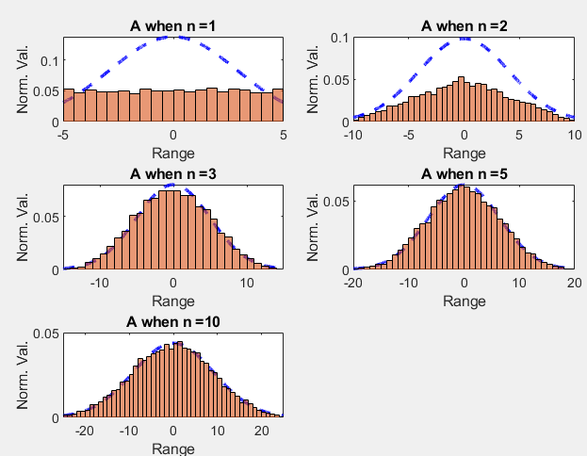In this question, we are asked to find sum of uniform random variables with different n values. As we increase n, A approaches to a Gaussian distribution.

As we increase the number of samples, Gaussian dist. goes up (b) and as we increase the range of uniformity, histogram goes up(c).

For A:

mu=0, sigma=(n*((range width)^2)/12)^(1/2)

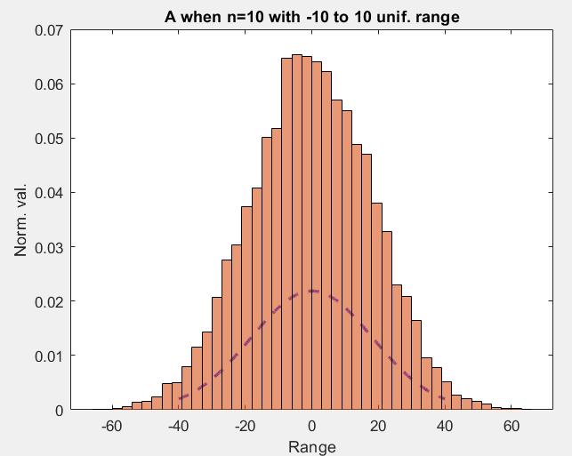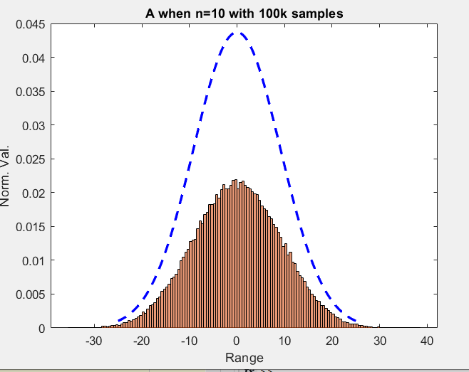

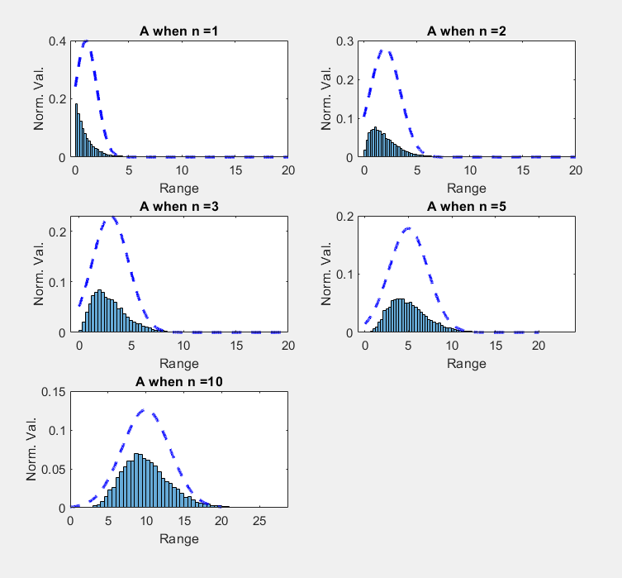3rd Question:

In this question, we are asked to find sum of exponential random variables with different n values. As we increase n, A approaches to the corresponding Gaussian distribution but this approach is relatively weak relative to the uniform distribution case.

Just like we have observed before, as we increase the number of samples, Gaussian dist. goes up and as we increase λ, histogram moves away from the y axis and Gaussian dist. comes closer to y axis because of the change in its mu.

For A:

mu=n/ λ, sigma=(n/λ^2) ^(1/2)

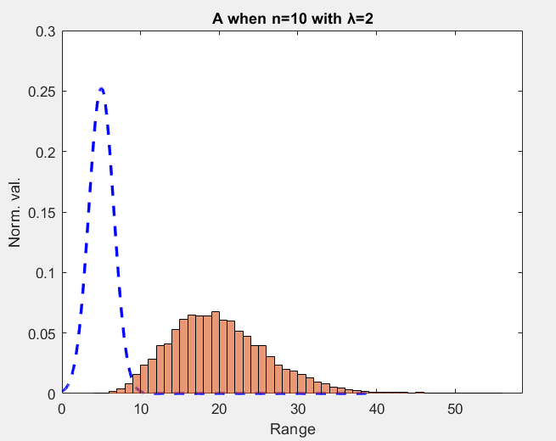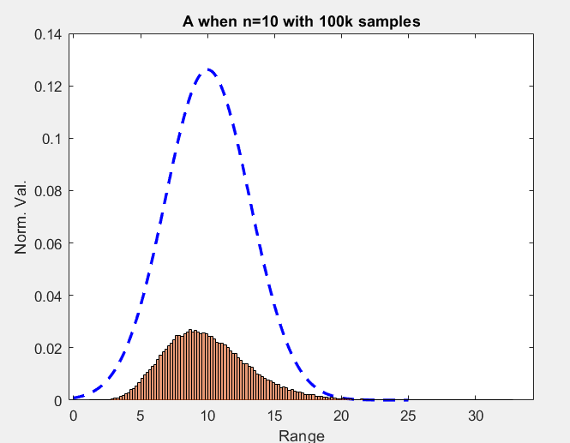

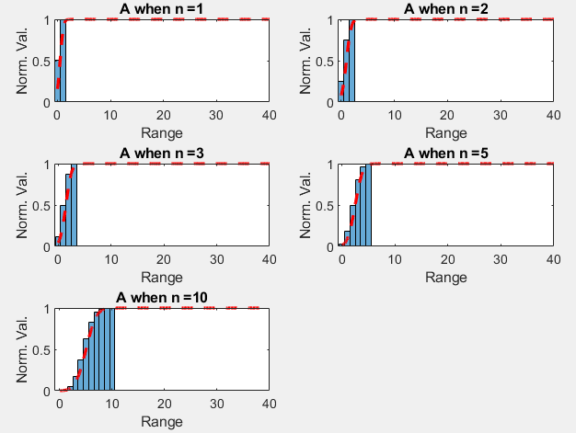4th Question :

In this question, we are asked to find sum of Bernoulli random variables with different n values. As we increase n, CDF of A approaches to the corresponding Gaussian CDF.

As we increase the number of samples and as we lower the probability from 1 to 0.75, Gaussian CDF is still close enough for both cases.

For A:

mu=n.p, sigma=(n*p*(1-p))^(1/2)

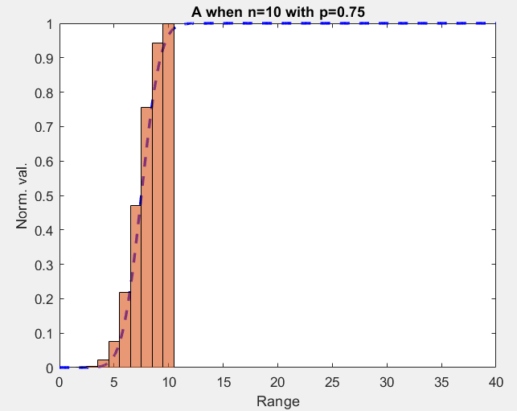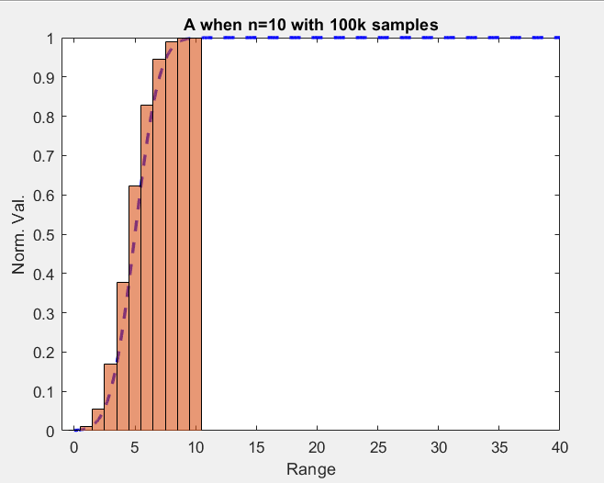

5th Question :

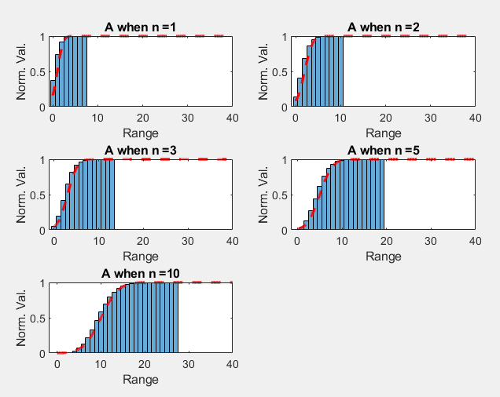In this question, we are asked to find sum of Poisson random variables with different n values. As we increase n, CDF of A approaches to the corresponding Gaussian CDF.

As we increase the number of samples and as we increase λ from 1 to 2, in both cases, CDFs are still close enough to each other.

For A:

mu= n*λ, sigma=(n*λ)^(1/2)

